**Name: JIDEAMA Nzubechukwu Chinemerem**

**Department: Electronic and Electrical Engineering**

**Matric Number: EEG/2015/153**

**Date: 5th/November/2022**

These are the challenges that I encountered in using LaTex thesis template and my way around them.

1. One of the major challenges that I encountered was been able to add images to the thesis template, positioning the images as instructed and also linking the figures where mentioned to the respective image or figure.

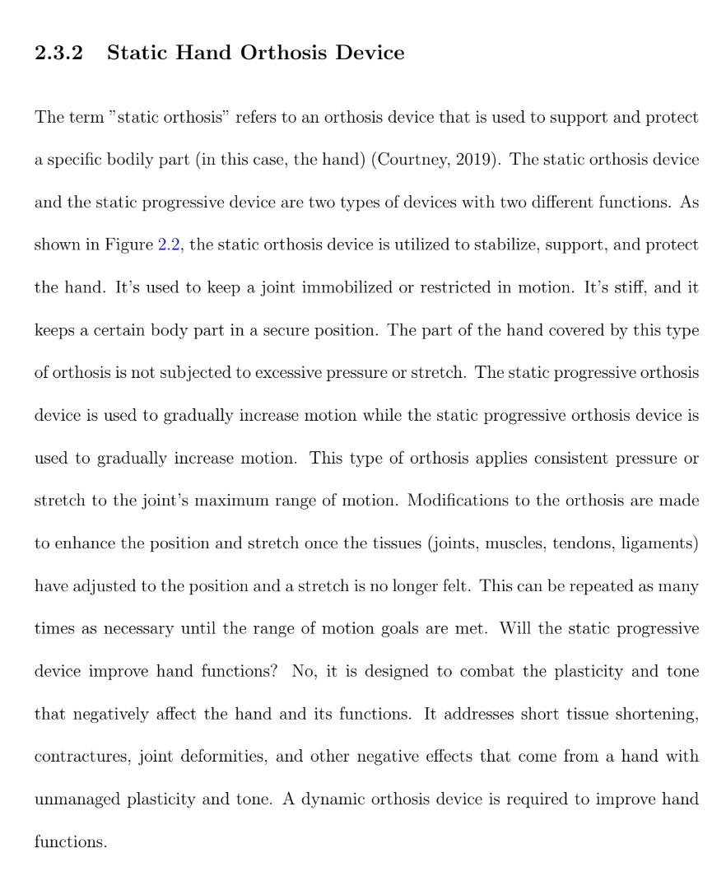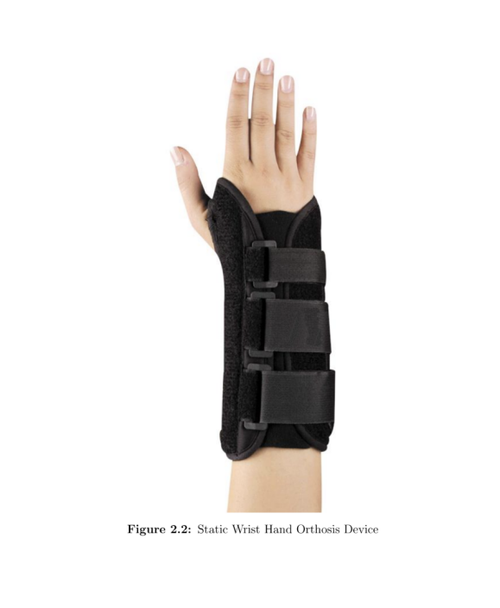

I was able to sort this challenge by going through the LaTex documentation.

1. Secondly, I encountered a big challenge when expressing mathematical equations. It was not straightforward as using Word Document which I was already used to. I had to use some representations/annotation to get the desired outcome and I was also able to overcome this by going through some tutorial videos that gave me a good explanation.

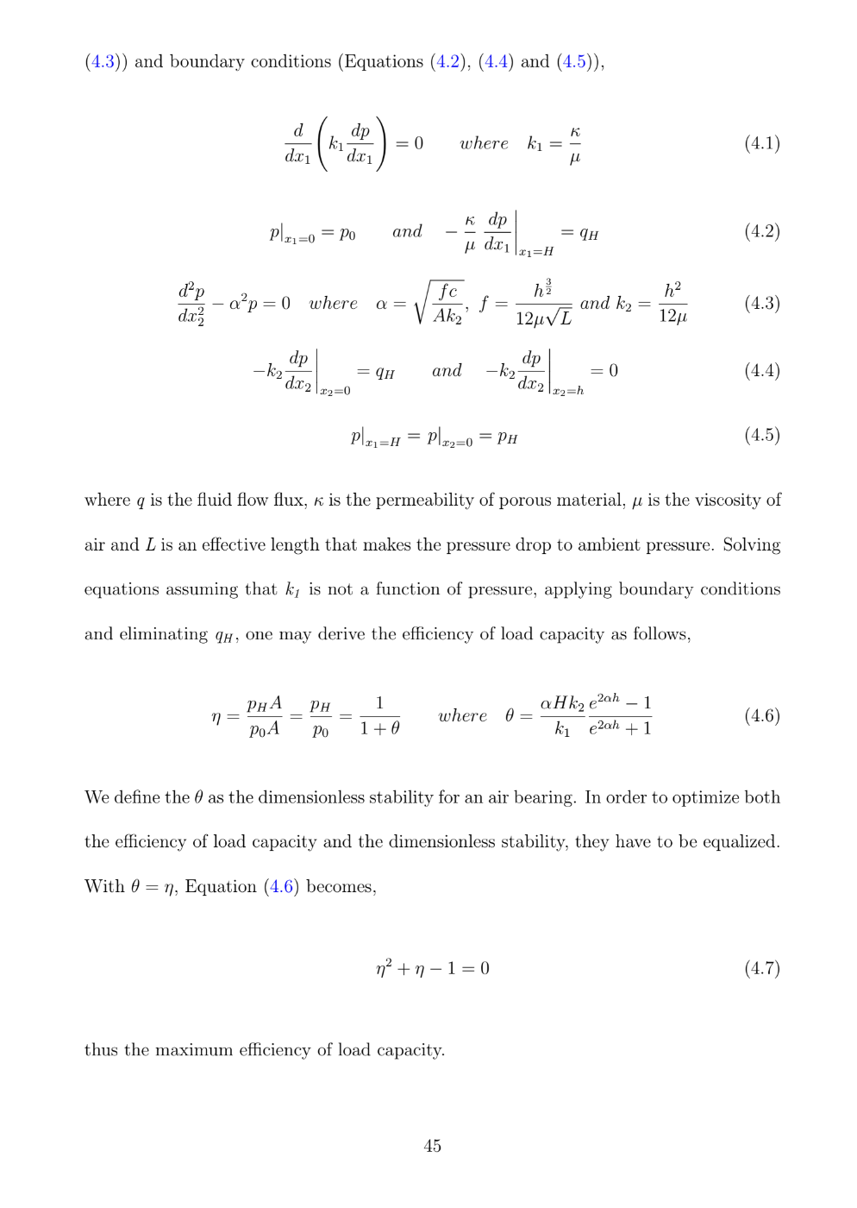

1. I couldn’t find it easy to depict table in the LaTex thesis template as required, so I had to read through the LaTex documentation again to understand tables better and I was able to sort it out and also link it to the list of tables afterwards and places mentioned.

